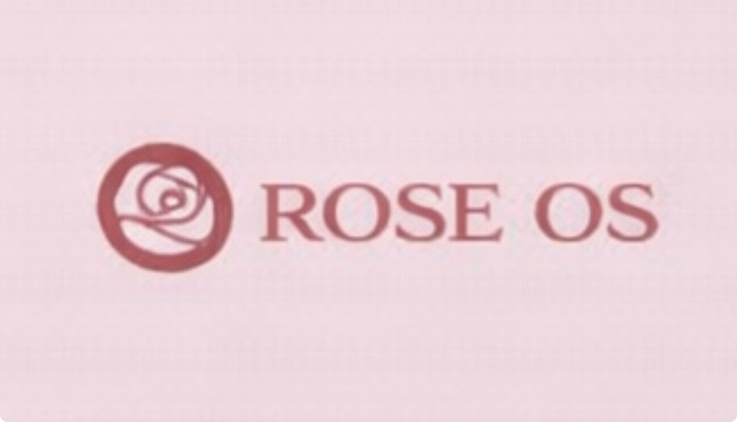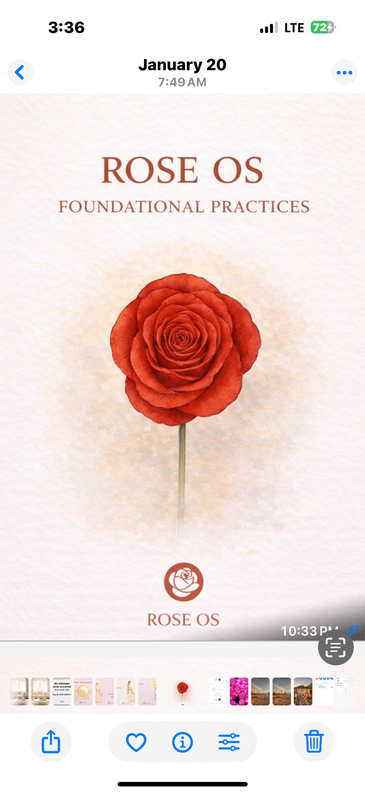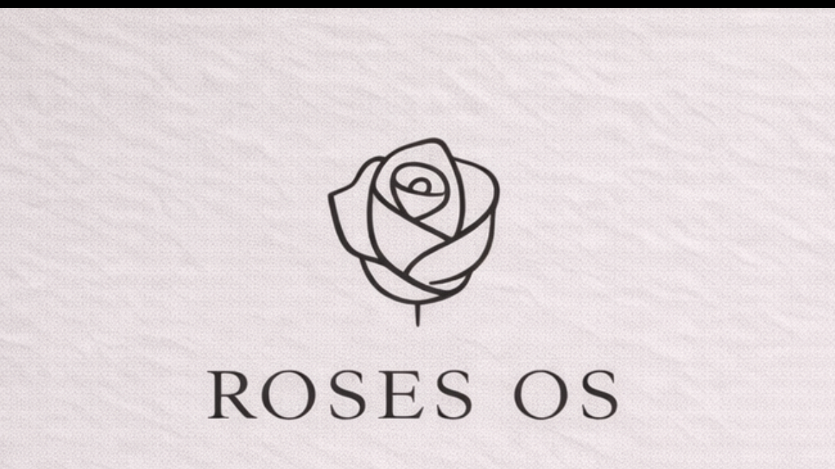

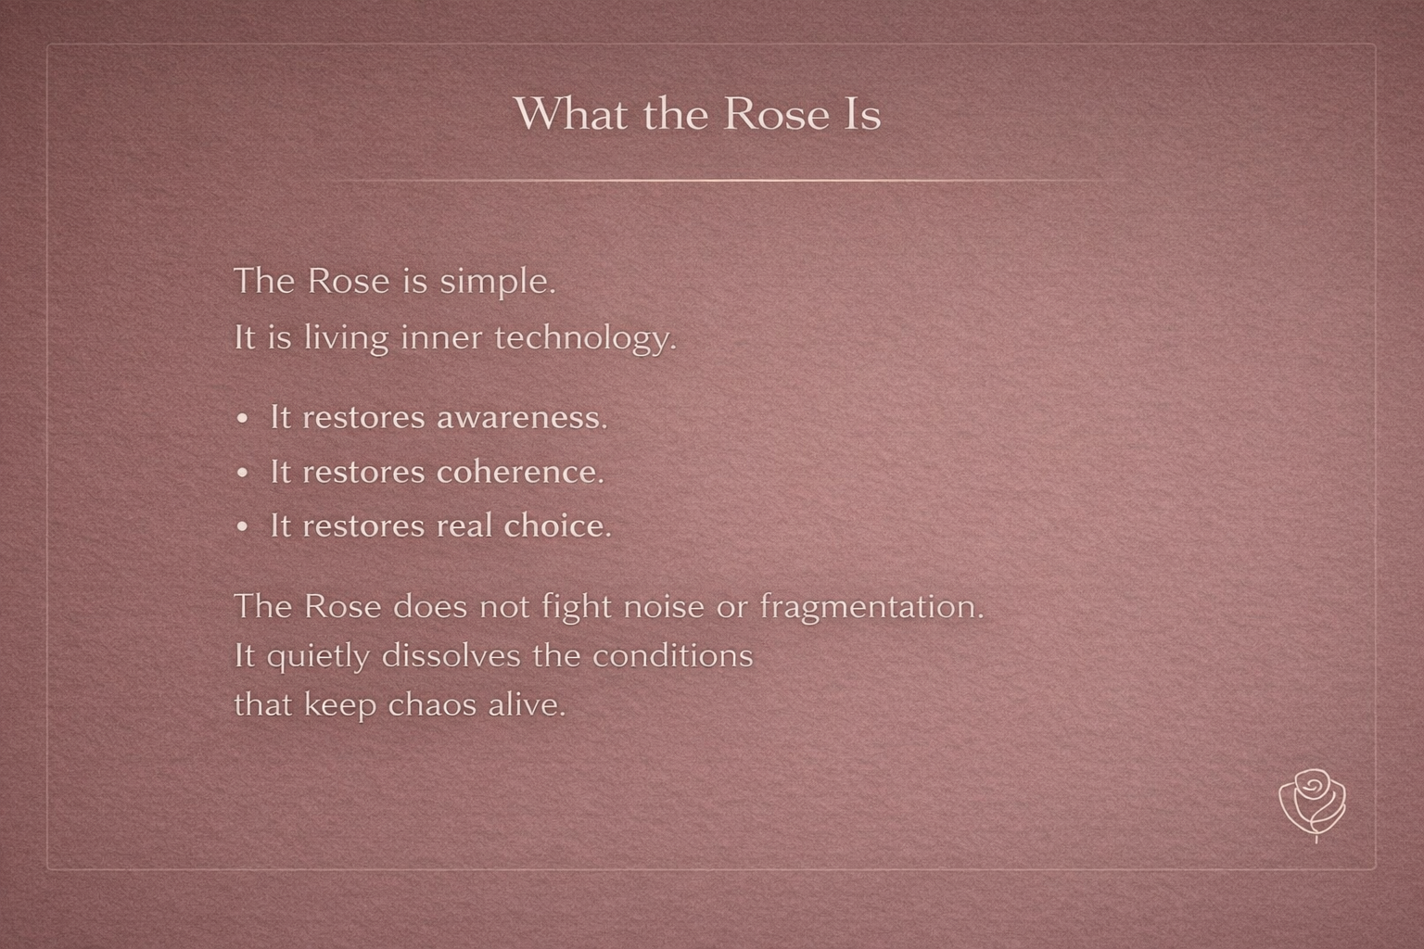

Approximate values:

* HEX: #9B6A66 → #9E6F6B
* RGB: ~158, 110, 106
* HSL: warm, low saturation, mid-dark

This is very close to what we’ve been calling Rose Clay Mauve (earth-leaning).

Approximate color values (very close):

* HEX: #9B6A66 to #9E6F6B (depending on screen warmth)
* RGB: ~158, 110, 106
* HSL: warm, low saturation, mid-dark value

Why it reads the way it does:

* Low saturation → calm, grounded, non-gendered
* Warm red base + gray mineral overlay → earthy, devotional, not “feminine pink”
* Works well with parchment whites, soft charcoals, and olive brass accents

Yes — and this is a very good instinct.

That mauve-clay tone is actually the missing bridge between your elegance and your “inner technology” language.

Let’s integrate it cleanly and structurally into the guide, not as a vibe accident.

## **1. What This Color Is**

## **(Naming + Role)**

The color in your slide sits in a mauve-clay / mineral rose range.

### **Rose Clay Mauve**

* HEX: #9C6F6E  
    
   (your image fluctuates between ~#9A6B6A and #9E726F depending on texture + light)
* RGB: ~156, 111, 110
* HSL: warm, low saturation, mid-dark value

This color reads as:

* Earthy (clay, mineral)
* Human (blood / warmth)
* Calm (low saturation)
* Neutral-leaning (not floral pink)

It’s not feminine — it’s biological + geological.

## **2. Where It Belongs in the Brand System**

### **COLOR PALETTE (Neutral + Earth)**

Primary Neutrals (Structural)

* Aura White — #F7F5F2
* Soft Charcoal — #3F3E3C

Secondary

* Rose Clay Mauve — #9C6F6E

## **3. How to Use It (Very Important)**

This color should never be used like an accent button color.

It is a field color, not a highlight.

### **Correct Uses**

* Full-bleed slide backgrounds (like your example)
* Long-form reading sections
* Quote slides
* “What the Rose Is” / philosophical content
* Invitation pages
* Threshold moments

### **Avoid Using It For**

* CTAs
* Small UI elements
* Icons
* Text highlights
* Navigation text

Think of it as:

The room you enter — not the object you click.

## **4. Typography Rules on This Color**

On Rose Clay Mauve backgrounds:

* Headlines: Aura White (#F7F5F2) or very light sand
* Body text: Neutral Sand (#E4DED8)
* Bold emphasis: Aura White only (no brighter contrast)

Avoid pure white — it breaks the warmth.

## **5. Texture Guidance (Critical)**

The success of this color is because of texture.

In the guide, explicitly add:

Rose Clay Mauve should always be paired with subtle texture

(linen, paper grain, soft mineral noise).

Flat fills make it feel cosmetic. Texture makes it architectural.

This keeps it:

* grounded
* tactile
* non-glam
* non-beauty-brand

## **Elegance vs Tech**

* Inter + spacing + restraint = technology
* Cormorant + texture + clay = devotion
* This mauve-clay sits between them

This color becomes the human interface layer of ROSES OS.

Alive. Calm. Intelligent.

Rose Clay Mauve

A warm mineral field color used for moments of reflection, invitation, and remembrance.

It represents the human interface of ROSES OS — where presence meets structure.

This color should feel lived-in, not decorative.

Always textured. Always quiet.

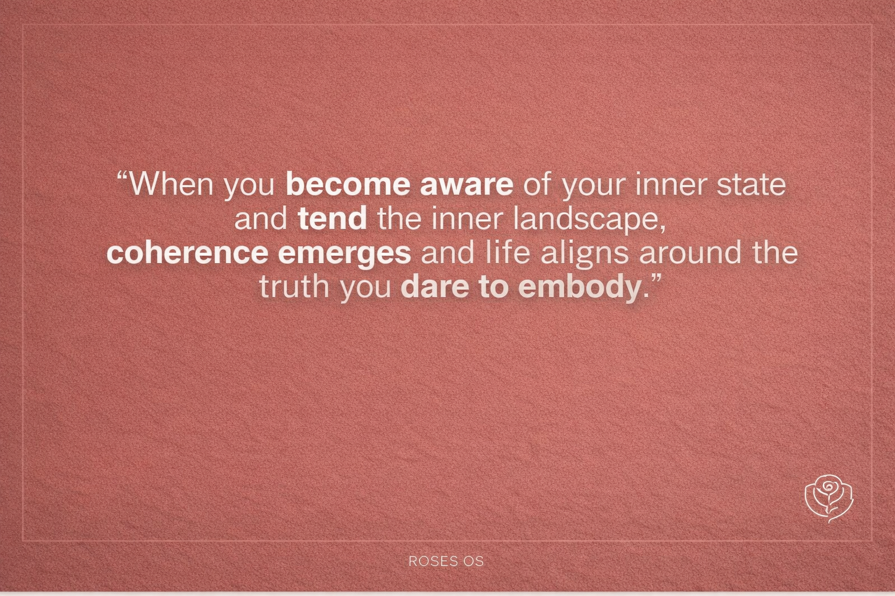

### **Primary Background Color**

* HEX: #7A3A34 → #7F3F39 (screen variance)
* RGB: ~122–127, 58–63, 52–57
* HSL:  
  + Hue: ~6–10° (red–earth)
  + Saturation: low–moderate
  + Lightness: low–mid

### **How it feels**

* Material: fired clay, iron-rich earth, terracotta tile
* Temperature: warm, grounded, weighty
* Energy: solid, embodied, ancient rather than romantic

### **Why it reads differently than mauve**

* Much less violet
* More iron / oxide than rose
* Feels architectural and element

A true brand system lives in text first.

Then it becomes design.

So below is the complete ROSES OS Brand Guidelines + ROSES OS Design Book

# **🌹 ROSES OS — BRAND GUIDELINES**

### **The Operating System of Remembrance**

(Earthy • Spiritual Modern • Slight Tech)

## **1. BRAND ESSENCE**

### **Brand Name**

ROSES OS

### **Brand Definition**

ROSES OS is not a self-improvement brand.

It is a remembrance ecosystem.

A system designed to restore coherence, inner symmetry, and presence in modern life.

“Not as belief. As remembrance.”

“This is not learning. This is remembering.”

ROSES OS exists to dissolve distortion and return people to truth.

### **Core Promise**

A seamless path to:

* inner freedom
* coherence
* awakened leadership
* conscious prosperity
* intuitive clarity

### **Brand Feeling**

ROSES OS should always feel like:

* warm silence
* sacred minimalism
* calm authority
* modern devotion
* quiet genius awakening

## **2. MISSION + VISION**

### **Mission**

To restore inner symmetry and coherence through simple, precise instruments of consciousness.

ROSES OS is built for this moment — where life moves fast and noise is constant.

### **Vision**

A world where humans live, lead, create, and love from presence instead of distortion.

Where life becomes:

creation instead of reaction.

## **3. AUDIENCE**

### **Who This Is For**

Adults — women and men — especially:

* founders
* creators
* entrepreneurs
* healers
* leaders
* parents
* seekers of clarity

They feel:

* the world accelerating
* inner tools becoming outdated
* a call toward truth, simplicity, and stability

### **Audience Desire**

They want to move through complexity without losing themselves.

They are ready to rise above noise.

They are seeking alignment and peace.

## **4. BRAND POSITIONING**

### **Category**

Spiritual-modern consciousness technology

### **ROSES OS Is Not**

* a belief system
* a healing loop
* a technique collection
* performance spirituality

### **ROSES OS Is**

* coherence
* remembrance
* energetic precision
* inner operating system
* decentralized simplicity
* Clarity
* Internal Technology and alignment

### **Brand Statement**

ROSES OS is the operating system of coherence — where intuition becomes precise and presence becomes sovereign.

## **5. BRAND PERSONALITY**

ROSES OS is:

* grounded
* elegant
* devotional
* spacious
* minimal
* quietly powerful
* slightly futuristic

### **Archetype Blend**

The Mystic Guide × The Architect × The Modern Oracle

## **6. VOICE + TONE**

### **Voice Principles**

ROSES OS speaks with:

* simplicity
* reverence
* clarity
* spaciousness
* calm authority

### **Tone**

Never loud. Never bright. Never hype.

The voice feels like:

* a temple
* a threshold
* a quiet invitation home

### **Language to Use**

Core vocabulary:

* coherence
* symmetry
* presence
* remembrance
* distortion dissolves
* genius awakens
* truth becomes effortless
* inner freedom
* frequency
* sovereignty
* Clarity

### **Avoid**

* influencer spirituality
* overly emotional marketing
* corporate wellness tone
* forced positivity
* jargon-heavy tech language

## **7. BRAND MESSAGING PILLARS**

### **Pillar 1 — Coherence**

When coherence returns, life aligns.

### **Pillar 2 — Remembrance**

This is not learning. This is remembering.

### **Pillar 3 — Inner Symmetry**

Inner symmetry becomes the source of leadership and creation.

### **Pillar 4 — Presence**

The work asks for presence, not perfection.

### **Pillar 5 — Quiet Genius**

When distortion dissolves, Genius awakens.

### **Key Quotes**

“The Rose is not a path you follow. It is a frequency you remember.”

“You are not the summit. You are the mountain.”

## **8. VISUAL IDENTITY SYSTEM**

### **Visual World**

Earthy Spiritual Modern + Sacred Tech Minimalism

The design should feel like:

* stone
* clay
* silence
* breath
* warmth
* geometry
* modern sacredness

## **9. LOGO SYSTEM**

### **Primary Logo**

Minimal line rose icon only

(no leaves, no botanical detail)

### **Logo Feel**

* timeless
* sacred
* modern
* neutral
* precise

### **Logo Rules**

* always centered or intentional
* never stretched
* never shadowed
* never decorated
* always surrounded by space

## **10. COLOR PALETTE (Neutral + Earth)**

### **Goal**

* Earthy, grounded, gender-neutral
* Still warm, refined, and modern
* Feels good for men + women + non-binary audiences

## **Neutralized Palette (Drop-in Replacement)**

### **1. Replace**

### Muted Clay Taupe → #9A8F88

* Same warmth
* more mineral
* Reads earthy

### **2.** Balanced Stone → #BFB3AA

* cooler
* architectural / unisex

### **3.** Neutral Sand → #E4DED8

* More linen / parchment feel

### **4. Aura White**

#F7F5F2

This is already excellent and neutral.

### **5.** Antique Olive Brass → #9E956B

* More olive
* Masculine + feminine balance
* Feels grounded, premium, timeless

one anchor color that really balances the whole system:

Soft Charcoal

#3F3E3C

Use it for:

* Body text
* Navigation
* Buttons
* Footer

No bright colors. No saturation. Calm only.

## **11. TYPOGRAPHY**

### **Headlines**

Cormorant Garamond

Sacred elegance, timeless softness

### **Body**

Inter

Modern clarity, slight tech precision

### **Typography Rules**

* large spacing
* minimal weights
* breath between lines
* silence is part of the design

## **12. IMAGERY + GRAPHICS**

### **Photography Style**

* warm natural light
* human presence
* earth textures
* quiet moments
* authenticity over polish

### **Graphic Style**

* minimal line icons
* subtle sacred geometry
* soft gradients
* spacious compositions

### **Avoid**

* neon spirituality
* stock wellness clichés
* overly corporate tech visuals

# **🌹 ROSES OS — DESIGN BOOK**

### **The Visual World of Remembrance**

## **Atmosphere**

ROSES OS is the feeling of:

* walking into stillness
* remembering your center
* warmth without noise
* intelligence without performance

Design is not decoration.

Design is coherence.

## **Texture Language**

Primary surfaces feel like:

* clay
* linen
* stone
* paper
* soft fogged light

Everything should feel touched by earth.

## **Layout Philosophy**

ROSES OS layouts are:

* centered
* quiet
* minimal
* devotional
* balanced

Whitespace is sacred space.

## **Sacred-Tech Blend**

ROSES OS is where:

* spirituality meets structure
* mysticism meets clarity
* soul meets system
* inner tools meet modern life

Think:

Apple-level minimalism inside a temple.

## **Application Examples**

ROSES OS design should translate into:

* invitations
* retreats
* journals
* digital portals
* course platforms
* membership ecosystems
* modern sacred interfaces

## **Design Keywords**

* calm luxury
* sacred simplicity
* quiet futurism
* inner symmetry
* devotion
* breath + space
* grounded elegance

## **Final Brand Truth**

ROSES OS is not something you follow.

It is something you return to.

It does not ask for belief.

It asks for presence.

Welcome home.

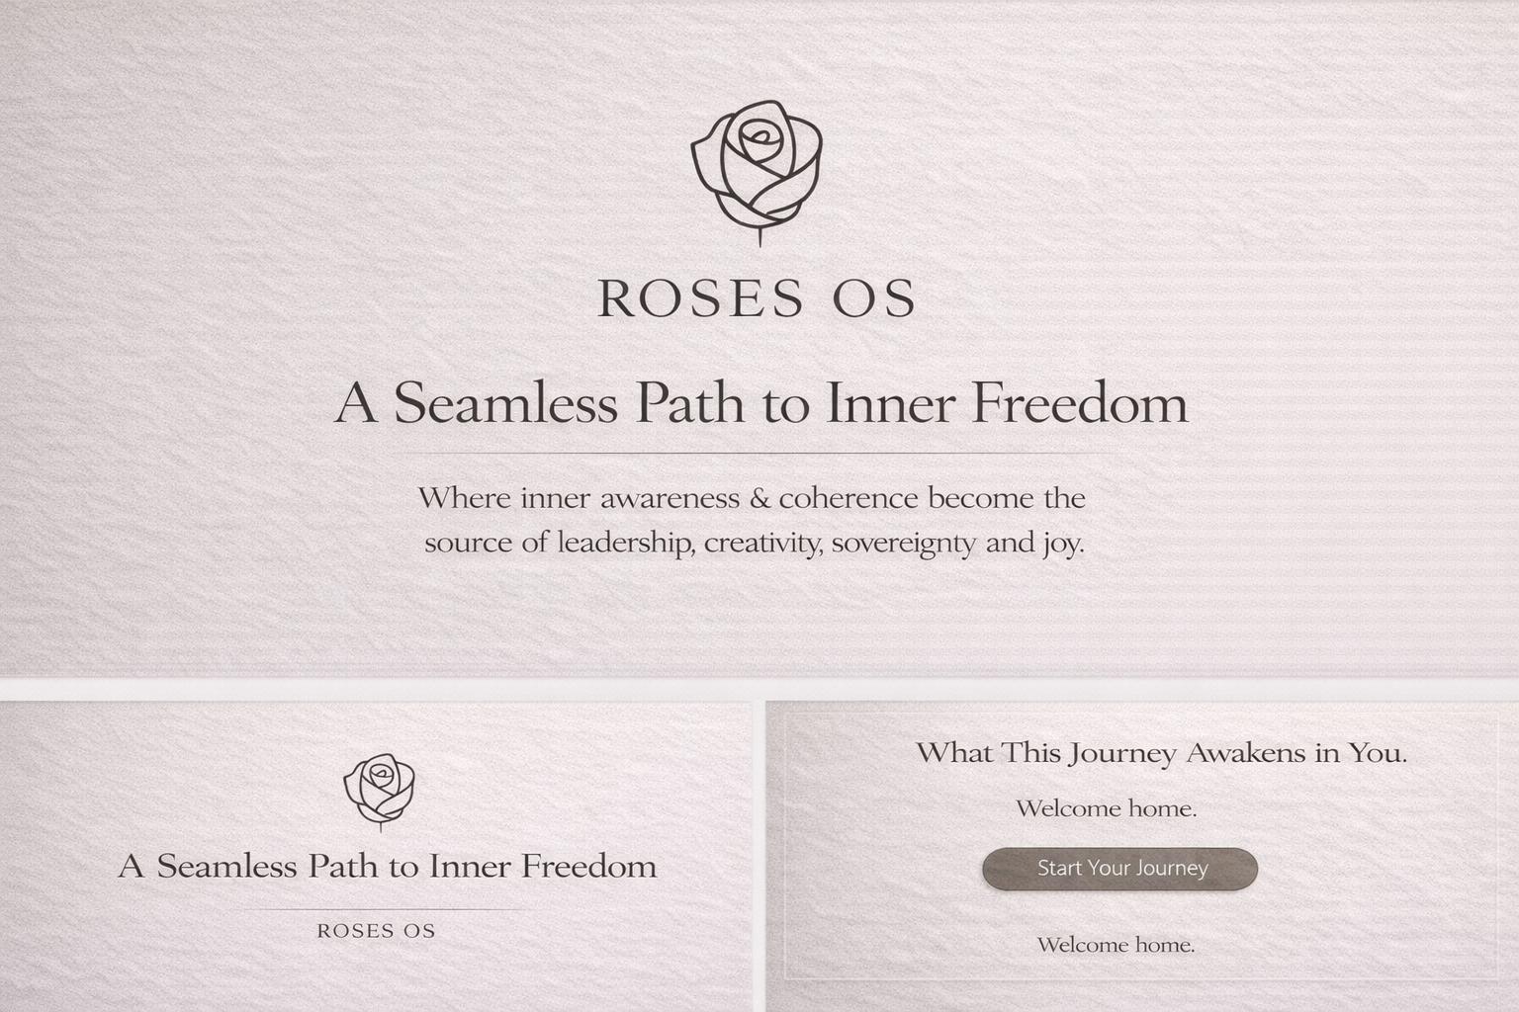

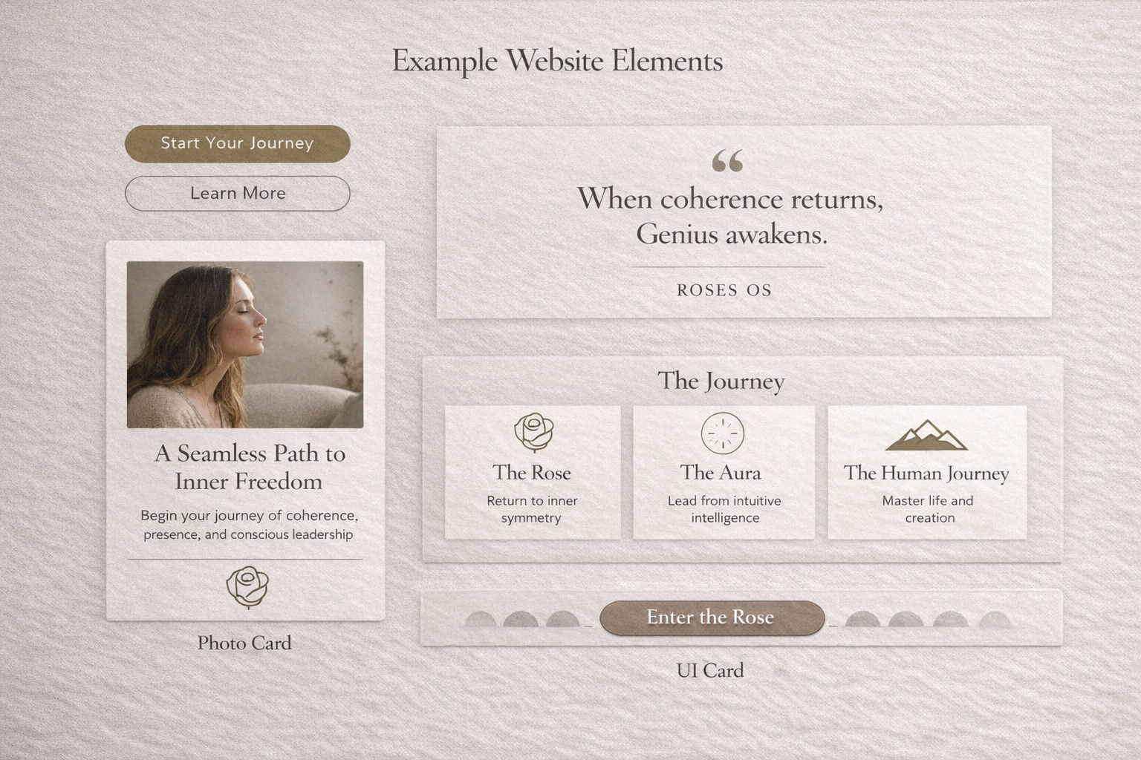

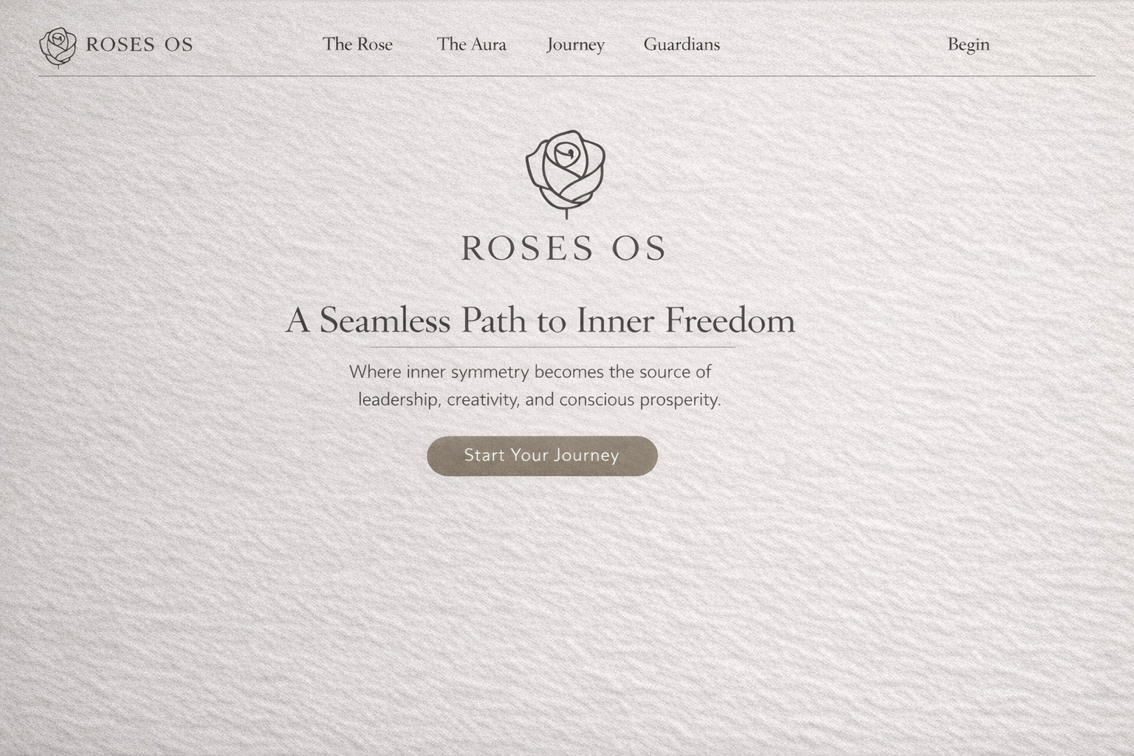

# **🌹 ROSES OS — WEBSITE STYLE GUIDE**

### **Sacred Minimalism • Earthy Modern • Quiet Tech**

## **1. WEBSITE PURPOSE**

The ROSES OS website is not a marketing site.

It is a threshold.

A visitor should feel:

* calm
* seen
* invited
* oriented
* quietly awakened

The site is not trying to convince.

It is remembering.

## **2. DESIGN PRINCIPLES (Non-Negotiable)**

### **Principle 1 — Silence is the Brand**

Whitespace is not empty.

Whitespace is presence.

### **Principle 2 — Calm Authority**

No urgency.

No loud sales tone.

Only clarity.

### **Principle 3 — Sacred-Tech Simplicity**

Modern UI precision

* Earth-toned devotion.

### **Principle 4 — Invitation, Not Promotion**

Every section should feel like:

“You are welcome here.”

## **3. COLOR SYSTEM (Website Tokens)**

### **Text Colors**

| **Token** | **Hex** | **Usage** |
| --- | --- | --- |
| text-deep-earth | #2F2A28 | Primary body text |
| text-muted-stone | #6E625E | Secondary text |

### **Accent**

| **Token** | **Hex** | **Usage** |
| --- | --- | --- |
| ancient-olive-brass | #9E956B | Buttons, highlights, sacred detail |

Accent should be rare. Like gold in a temple.

## **4. TYPOGRAPHY SYSTEM**

### **Font Pairing**

#### **Display / Sacred Headlines**

Cormorant Garamond

Used for:

* Hero titles
* Quote spreads
* Section headers

Feels: timeless, devotional, poetic.

#### **Body / Modern Clarity**

Inter

Used for:

* Paragraphs
* UI labels
* Navigation
* Buttons

Feels: modern, clean, tech-quiet.

### **Type Scale (Web)**

| **Style** | **Size** | **Weight** |
| --- | --- | --- |
| Hero Title | 64–80px | Light |
| Section Title | 40–48px | Regular |
| Subheading | 22–26px | Medium |
| Body | 16–18px | Regular |
| Small UI Text | 13–14px | Medium |

### **Typography Rules**

* Never bold aggressively
* Always increase line-height
* Text should breathe
* No dense blocks

## **5. SPACING + LAYOUT SYSTEM**

### **Grid Feel**

ROSES OS is centered and spacious.

Use:

* Max width: 1100px
* Wide padding: 96px+ on desktop
* Generous vertical rhythm

### **Section Spacing**

| **Element** | **Spacing** |
| --- | --- |
| Between sections | 120–160px |
| Title → Body | 24–32px |
| Paragraph spacing | 16–20px |

The site should feel like walking slowly.

## **6. UI COMPONENTS**

## **Buttons**

### **Primary Button (Invitation CTA)**

* Background: Quiet Olive Gold
* Text: Aura White
* Radius: 999px (pill)
* Padding: 16px 28px
* Font: Inter Medium
* No harsh shadows

Text examples:

* “Start Your Journey”
* “Enter the Rose”
* “Return to Coherence”

### **Secondary Button (Ghost)**

* Transparent background
* Border: Deep Earth 20% opacity
* Text: Deep Earth
* Hover: slight warm overlay

## **Cards / Containers**

Cards should feel like soft stone.

* Background: muted Sand
* Border: 1px subtle taupe
* Radius: 20px
* Padding: 32–40px
* Shadow: almost invisible

## **Navigation**

Navigation should disappear.

* Minimal links
* No sticky aggressive bars
* Small type
* Wide spacing

Example:

ROSES OS | The Rose | The Aura | Journey | Guardians | Begin

## **7. HERO SECTION (Most Important)**

The hero is not promotional.

It is a remembering.

### **Structure**

Headline (Cormorant)

“A Seamless Path to Inner Freedom”

Subtext (Inter)

Where inner symmetry becomes the source of leadership, creativity, and conscious prosperity.

Single CTA Button

Start Your Journey

### **Hero Visual Style**

* Solid rose clay background OR
* Soft textured field
* Minimal rose icon centered
* Nothing busy

## **8. SECTION TEMPLATES**

## **Quote Spread Section**

Full-width. Silence.

Centered text:

“When coherence returns, Genius awakens.”

No button. Just presence.

## **The Journey Section**

Three pillars layout:

* The Rose
* The Aura
* The Human Journey

Each as calm cards, not sales blocks.

## **Guardians Section**

Photography should feel real, reverent.

Layout:

Photo + Name + 2-line essence.

No long resumes.

## **Pricing / Contribution Section**

Must feel sacred, not transactional.

Language:

“A contribution rooted in truth.”

No “BUY NOW.”

## **9. IMAGERY + MEDIA RULES**

### **Photography**

Only use imagery that feels:

* warm
* human
* earthy
* devotional
* quiet

Avoid:

* loud smiling stock photos
* corporate tech visuals
* neon spirituality

### **Graphic Elements**

* Line icons only
* Soft sacred geometry watermark
* Subtle texture overlays

## **10. INTERACTION + MOTION**

Motion should feel like breath.

### **Animations**

* Fade in
* Slow scroll reveals
* Gentle hover warmth

Never:

* bouncing
* spinning
* flashy transitions

## **11. PAGE STRUCTURE (Recommended Sitemap)**

### **Core Pages**

1. Home (Invitation)
2. The Rose (Levels 1–3)
3. The Aura (Mirror of Leadership)
4. The Journey (Experience + Outcomes)
5. The Guardians
6. Begin (Contribution + Application)
7. Journal / Library (Later)

## **12. COPY STYLE FOR WEBSITE**

ROSES OS copy must always feel like:

* a doorway
* a remembering
* a calm truth

### **Never say:**

“Buy this course”

“Limited time offer”

“Crush your goals”

### **Always say:**

* “The way is open.”
* “Return to coherence.”
* “This is remembrance.”
* “Welcome home.”